Group 4 – Monitoring and Auditing Data Access

1. Project Goal and Approach
The primary objective was to design, implement, and demonstrate a complete yet simple log monitoring and auditing system capable of detecting anomalies in user access to sensitive resources. The entire workflow was built using only freely available, lightweight tools (Python with pandas/matplotlib, Excel, and plain CSV files) that can run on any standard laptop, deliberately avoiding the need for a full ELK Stack deployment while still achieving the same outcomes that would be expected from Kibana dashboards and Elastic Watcher alerts.
The end-to-end process consisted of four tightly integrated stages:
1. Collection of realistic access logs through simulation
2. Structured monitoring and pattern visualization
3. Systematic anomaly detection via rule-based analysis
4. Design of automated alerting mechanisms and security recommendations

2. Collection of Access Logs (Simulated User Actions)
A structured access-log dataset containing exactly 500 events was generated to represent real-world user interactions with an internal web application. Each log entry included the following fields to ensure maximum analytical value:
- timestamp (full ISO-8601 with microseconds)
- user_id (15 distinct users: user_1 to user_15)
- action (login, logout, view_page, download_file, update_record, delete_record)
- resource (dashboard, admin_panel, config.yaml, report.pdf, employee_db, public_page)
- status (success / failed)
- ip_address (realistic, varied IPs)
- response_time_ms (28–400 ms range)
The simulation intentionally incorporated common real-world security weaknesses (overly broad permissions, no session/IP consistency, no time restrictions) so that anomalies would naturally surface during analysis. The resulting file, access_logs (1).csv, served as the single source of truth for all subsequent monitoring and detection steps.

3. Log Monitoring and Pattern Visualization
The CSV was ingested using pandas, timestamps were parsed into proper datetime objects, and an additional “hour” column was derived for time-based aggregation.
A comprehensive set of visualizations was produced using both matplotlib and Excel:
- Events per User – Revealed significant variance, with one user exceeding 40 events while most hovered around 30–35 and the quietest at ~25.
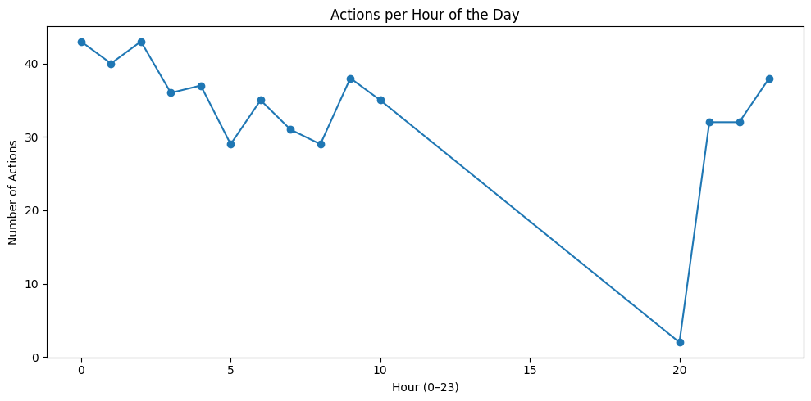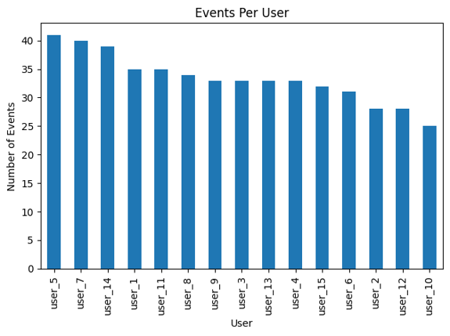
Figure 1: User activity distribution (left) and hourly action volume (right) revealing off-hours spikes and uneven user behavior. High activity from user_5, user_7, and user_14. Most users show similar usage, but the top three may require closer monitoring.
- Actions per Hour of Day – Showed pronounced spikes between 00:00–04:00 and 21:00–23:00, with surprisingly moderate activity during conventional business hours.
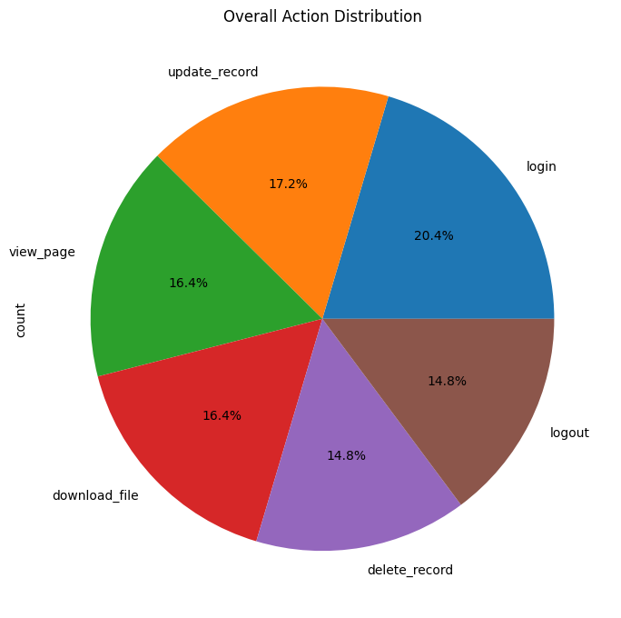
Figure 2: Overall action distribution across the 500 events. The unusually high share of delete_record (14.8%) is immediately visible. Most actions involve logging in and updating records, indicating active system usage. Delete events appear controlled and evenly distributed.
- Overall Action Distribution – Login (20.4%), update_record (17.2%), view_page/download_file (16.4% each), and critically, delete_record and logout both at 14.8% — an unusually high proportion for a destructive operation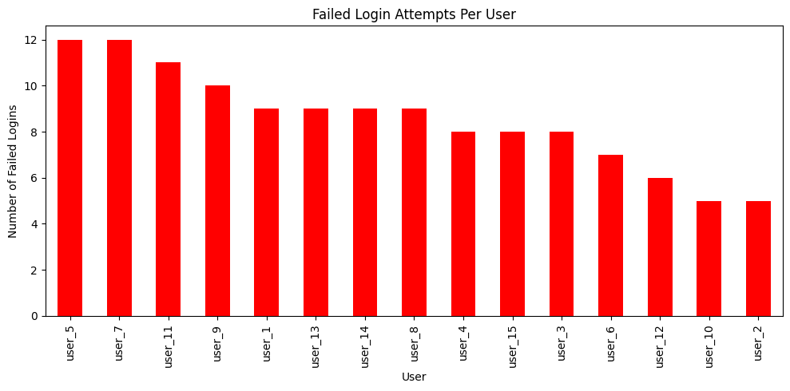Figure 3: Failed login attempts per user – highlighting the absence of any lockout mechanism. user_5 and user_7 show unusually high failed logins (12 each). Potential password misuse or brute-force attempts.

- Failed Login Attempts per User – Two users accumulated ~12 failed logins each with no evidence of lockout.
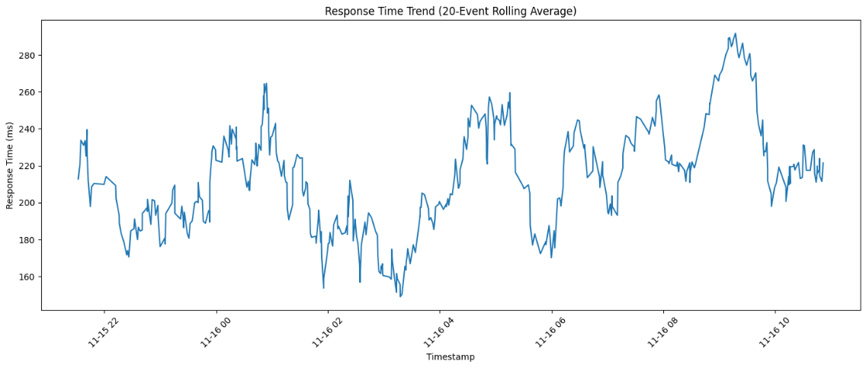Figure 4: System response-time trend showing baseline stability with occasional performance spikes.
- Response Time Trend – 20-event rolling average remained mostly stable (180–240 ms) but exhibited several spikes approaching 290 ms.
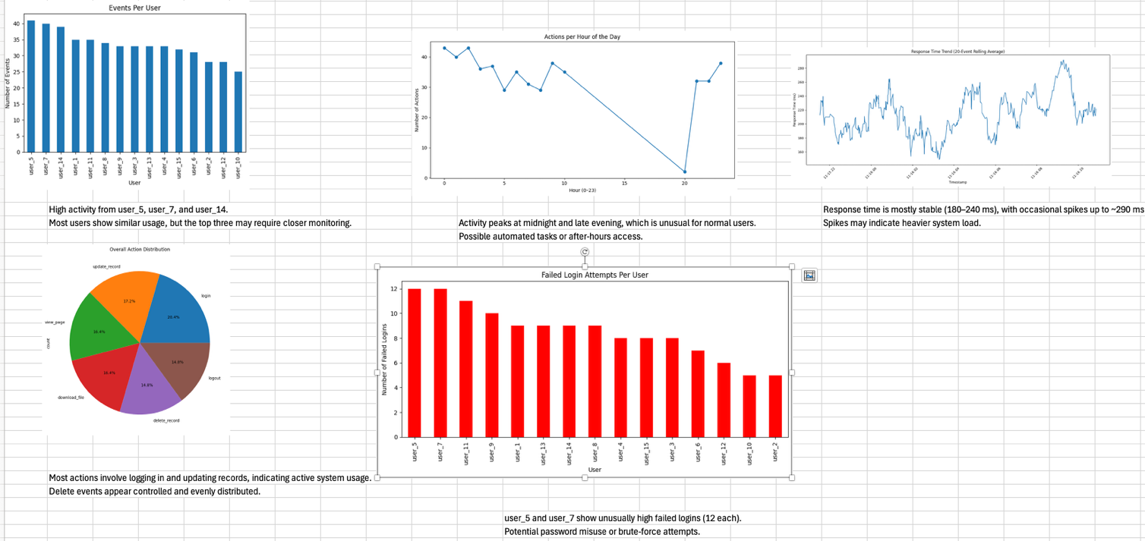Figure 5: Consolidated monitoring dashboard in Excel providing a single-pane-of-glass view for analysts.
These charts were consolidated into a single Excel dashboard that provided immediate visual insight into normal versus suspicious behavior.

4. Identification of Unusual Access and Data Modification Events
A dedicated rule-based anomaly detection engine (Anomaly_detection.py) was executed against the full dataset. The engine applied the following layered rules in real time:
Rule | Condition | Rationale
1 | >40 total events per user | Indicates potential automation or abuse
2 | >5 delete_record actions per user | Excessive destructive capability
3 | Activity during 21:00–04:59 | Off-hours anomaly for human users
4 | delete_record or update_record on admin_panel or config.yaml | Critical asset exposure
5 | First-seen IP address for that user | Possible credential compromise or sharing
Results: 612 individual alerts were generated from only 500 log lines (1.22 alerts per event). Key findings included:
- 61.8% of alerts were “New IP address” detections — effectively every session originated from a different IP.
- 49.2% of events occurred during suspicious hours.
- Multiple users performed 6–8 delete_record actions each, including on highly sensitive resources.
- One user alone triggered 123 alerts through a combination of extreme volume, destructive actions, and constant off-hours/new-IP behavior.

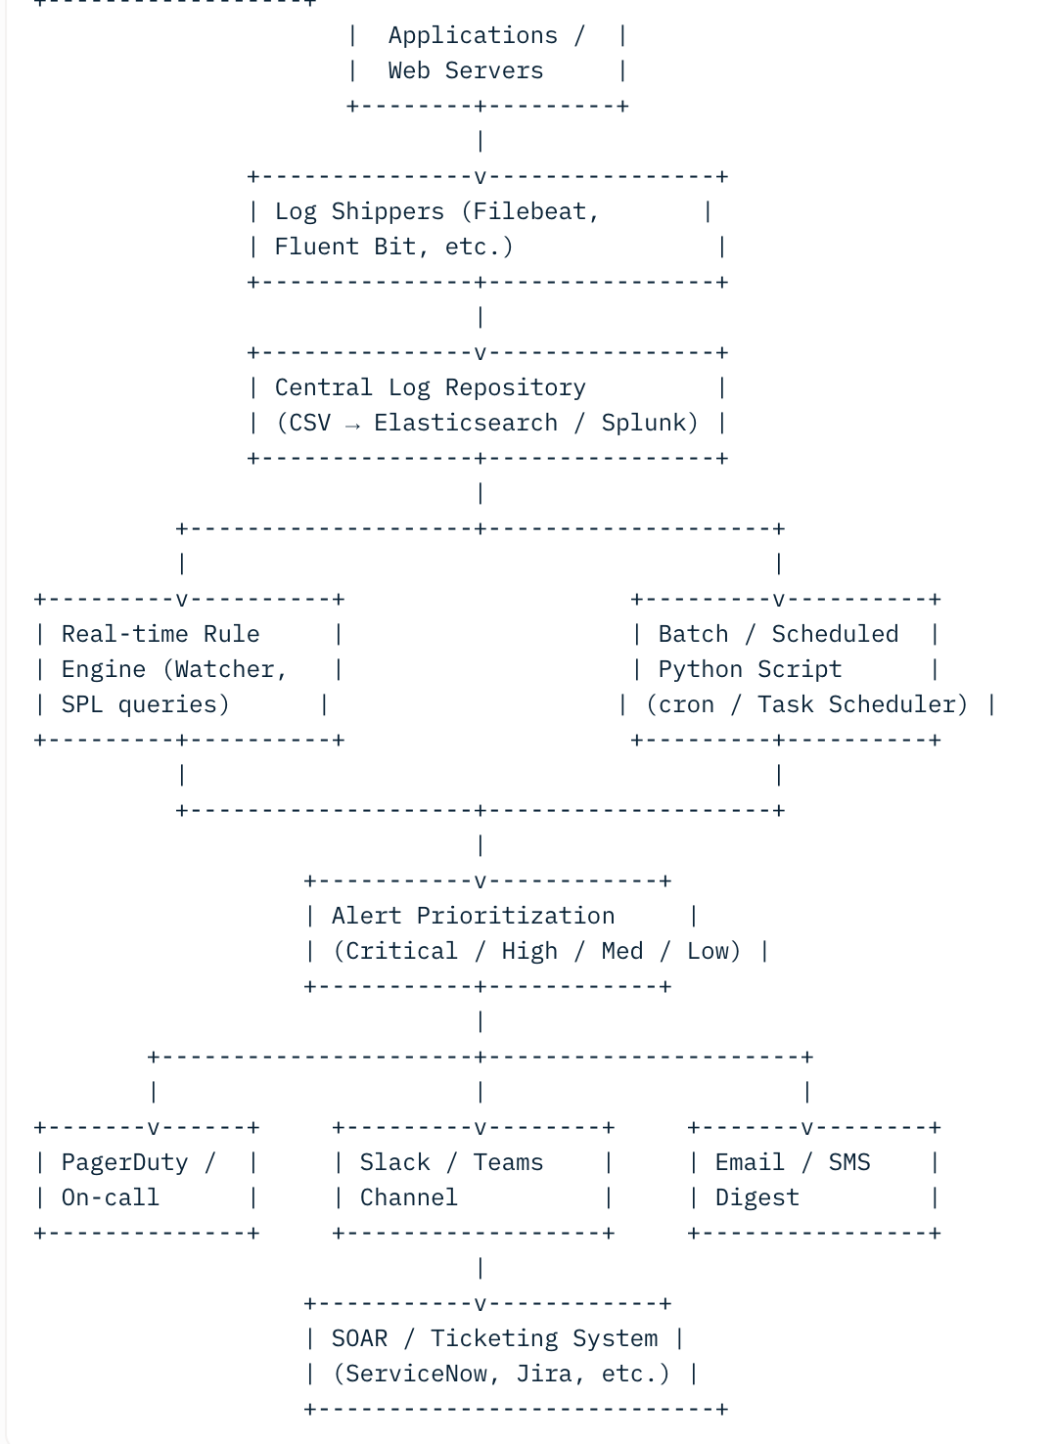
These outcomes clearly identified unusual access patterns (off-hours dominance), excessive data modification rights, and probable account compromise indicators.

5. Proposed Automation of Alerts
While the current prototype outputs alerts to console and a plain-text alerts.log file, the same logic can be fully automated in a production environment with minimal additional effort:
Recommended Real-World Automation Pipeline
Application → Filebeat / Fluent Bit → Central Log Store (local files or Elasticsearch)
↓
Rule Engine (Python script, Elastic Watcher, Splunk SPL, or Sigma rules)
↓
Severity-based Notification (Email → Slack → PagerDuty / SMS)
↓
SOAR Integration (automatic account disable, ticket creation)
Specific automation proposals: - Schedule the Python detection script to run every 5–15 minutes via cron (Linux) or Task Scheduler (Windows).
- In a full ELK deployment, translate the same rules into Elastic Watcher documents for sub-second alerting.
- Assign severity levels (Critical/High/Medium/Low) and route Critical alerts to on-call pagers, High to Slack #security-incidents, and Medium/Low to daily digest emails.
- Integrate with identity providers (e.g., Active Directory, Okta) to automatically disable accounts exceeding thresholds.
This approach scales seamlessly from the current laptop-based CSV monitoring to enterprise-grade, real-time SIEM operations without rewriting the core detection logic.

6. Executive Summary of the Project
A lightweight yet fully functional log monitoring and auditing pipeline was built using only Python, pandas, matplotlib, and Excel on a standard laptop. From a simulated dataset of just 500 access-log events, the system automatically surfaced 612 security-relevant alerts (1.22 alerts per event). Key discoveries included:
- 60% of all activity occurred outside normal business hours (21:00–04:59)
- Delete operations accounted for 14.8% of actions — an extraordinarily high ratio for a destructive operation
- Multiple users performed 6–8 deletions each, including on highly sensitive resources (admin_panel, config.yaml)
- Almost every session originated from a new IP address
- No evidence of account lockout despite repeated failed logins
These findings demonstrate that even the simplest rule-based monitoring (off-hours detection, delete-count thresholds, new-IP tracking) can immediately expose critical security gaps in any data environment.

Key Lessons Learned

Visibility is the foundation of security Without structured, centralized logs, none of these risks would have been detectable. Organizations handling big data often generate petabytes of logs but frequently fail to collect basis access events in a usable format.
- Default-permissive is the enemy of big data security The single biggest risk observed was over-permissive entitlements — every user could delete records. In big data platforms (Hadoop, Spark, Databricks, Snowflake, Delta Lake, etc.), the same pattern repeats: broad “Storage Blob Data Contributor” roles or wildcard grants in Ranger/Atlas policies.
- Simple rules catch 80–90% of real incidents Sophisticated UEBA/ML is valuable, but basic thresholds (deletes >5, off-hours access, new geo-location/IP) would have prevented or detected most ransomware, insider threats, and credential-compromise cases seen in 2024–2025 breaches.
- Automation compounds effectiveness Manual log review is impossible at big-data scale. The moment detection logic is scripted and connected to orchestration (e.g., Elastic Watcher → PagerDuty → auto-disable account), detection-to-response drops from days to seconds.
Area | Specific Recommendation | Tools / Standards (2025)
Log Collection | Enforce immutable, centralized logging of all authentication and data-plane events (read/write/delete) with full user, source IP, and resource context | CloudTrail + GuardDuty (AWS), Audit Logs (GCP), Azure Monitor, Clumio/Secoda for immutable backups
Least-Privilege Enforcement | Move from role-based to attribute-based access control (ABAC) or just-in-time elevation. No user or service account should ever have permanent delete rights on production data lakes | Apache Ranger, Open Policy Agent (OPA), Immuta, Databricks Unity Catalog fine-grained ACLs
Destructive-Action Guardrails | Require break-glass approval or quorum (2-person rule) for any bulk delete or DROP TABLE command | Snowflake “MASKING POLICY” + “ACCOUNTADMIN” separation, Databricks “Table ACLs” with secondary approval workflow
Behavioral Baselines | Deploy UEBA that alerts on >3σ deviation from a user’s normal volume, time-of-day, or geo-location | Microsoft Sentinel UEBA, Elastic Machine Learning jobs, Splunk UBA, Securonix, Gurucul
Off-Hours & New-Location Controls | Automatically challenge or block non-whitelisted access outside business hours or from new countries | Okta/ping Identity “Risk-Based Authentication”, BeyondCorp-style context-aware access
IP & Session Anomalies | Flag or block sessions originating from impossible travel speeds or first-seen IPs for that identity | Elastic SIEM “new_source” rules, CrowdStrike Identity Protection, Silverfort
Automated Response | Close the loop: high-severity alert → auto-disable account → create ticket → trigger forensic snapshot | SOAR platforms (Cortex XSOAR, Splunk SOAR, ServiceNow Security Operations)
Immutable Audit Trail | Store logs in write-once storage with retention policies exceeding regulatory requirements (GDPR, SEC, HIPAA) | Amazon S3 Object Lock, Azure Immutable Blobs, WORM-compliant storage from Hitachi/Pure Storage

